ETRSS-1 Satellite In-orbit Management Requirement

1 Summary
ETRSS-1 satellite will be delivered to user and go to in-orbit management stage. The article introduces the basic requirement of in-orbit management, important telemetry parameters and emergency handling requirement.
Telemetry criterion in this article are just reference range. Ultimate conclusion according to command and telemetry file and working state just at that moment.

2 current Status of satellite
The satellite telemetry state in-orbit management stage are as follows:
No | equipment | State | Telemetry | 备注
 | PSS | Battery Discharge switch status | NS011=0: on
 |  | Transponder 2 power switch status | NS012=1: on
 |  | Solar panel release power status | NS013=0: off
 |  | ±Y panel deployment power status | NS018=0: off
 |  | Overdischarge_protect_ENABLE | NH017=0: disabled
 |  | Battery automatically switch on ENABLE | NH018=1: enabled
 |  | Safe mode send unlock enable | NH019=0: disabled
 |  | OBC reset enable status | NH020=1: enabled
 |  | Batt_Heaters_Control_SETTINGS | NH022=40H（closed loop）
 |  | Batt_Balance__ENABLE | ND028=1: enabled
 | Transponder | Transponder powered on always | TA020：3~4V  TB020: 3~4V
 |  | Transmitter of transponder A powered on | TA001: 1(on)  TA016: 3.1~3.3
 | GPS | Highest carrier-to-noise ratio flag: ≥40dB | GS012:40～50dB;  or ≥50dB
 |  | Number of Available stars: >4 | GS003:4～14
 |  | TIC counter: cycle increase | GH001: 0～4294967295
 | OBDH | Safety_Mode_Task_ENABLE | XS132 =1: Enabled
 |  | TTC_Check_Error_Safety_Mode_Enable | XH150=1: Enabled
 |  | TTD_Check_Error_Safety_Mode_Enable | XH151=1: Enabled
 |  | Energy_protect_Safety_Mode(_triggered_by_PCU)_Enable | XH152=1 : Enabled
 |  | AOCS_Global_Attitude_Acquisition_Safety_Mode_Enable | XH153=1: Enabled
 |  | AOCS_Stop_Control_Safety_Mode_Enable | XH154=1: Enabled
 |  | Energy_warning_Safety_Mode_1_Enable | XH155=1: Enabled
 |  | Energy_warning_Safety_Mode_2_Enable | XH156=1: Enabled
 |  | Energy_protect_Safety_Mode(_triggered_by_TCU)_Enable | XH157=1: Enabled
 |  | CCD_temperature_Safety_Mode_Enable | XH158=1: Enabled
 |  | Phased_array_antenna_temperature_Safety_Mode_Enable | XH159=1: Enabled
 | DTS | Integrate Transmission Machine Work State | P2BW1B7=1：Loaded successfully
 |  | RF On/Off State | P2BW1B6=1：RF On
 |  | Ground Station marker | P4BW14B3~B0=1~7 Ethiopia ground station
 |  | Antenna Working mode | P4BW14B5~B4=1：Automatic computing Angle
 | camera | Stand-by mode(long) | MC-VOLTAGE 1 RM001=0~+0.3V  MC-VOLTAGE 2 RM002=0~+0.3V  MC-VOLTAGE 3 RM003=0~+0.3V  MC-VOLTAGE 4 RM004=0~+0.3V  MC-VOLTAGE 5 RM005=0~+0.3V
 |  | Image mode (short) | MC-VOLTAGE 1 RM001=+4.20~+4.90V  MC-VOLTAGE 2 RM002=+4.20~+4.80V  MC-VOLTAGE 3 RM003=+3.60~+4.20V  MC-VOLTAGE 3 RM004=+4.00~+4.60V  MC-VOLTAGE 4 RM005=+2.00~+2.60V

3 Basic principle of in-orbit management
- In normal working state of satellite, don’t switch working mode of satellite platform.
- If equipment of satellite switch the main/backup on its own，inform DFH in time;
- If the work mode of the satellite has changed to Global Attitude Acquisition Mode(AAM), inform DFH at once;
- The principle of fault tacking: Ensuring power supply, ensuring TT&C path and striving for more time to diagnose and upload.

4 Requirement of in-orbit management

4.1 Basic requirement
a. To make TT&C plan every week and to track the satellite 2~3 times every day.
b. To monitor telemetry and evaluate the satellite healthy status.
c. To determine the orbit for ETRSS-1 every day and to generate orbit data block.
d. To upload TCs and data block in line with the requirement in sec 4.2.
e. To upload the data blocks in line with the image task only in case of the satellite working in fully healthy status.
f. To check the result of each upload through TM.
g. To call DFH as soon as possible if any abnormal observed, and finish abnormal report in 1 day.

4.2 Telecommand requirement
a. To upload orbit data to satellite once everyday, orbit data time must be the time of the same day.
b. To upload telecommand “KSM35-01 TC_monitor_Timeout_Safety_Mode_counter_reset” to satellite once everyday.

4.3 Telemetry requirement
a. Tacking the downlink telemetry data in real time to monitor the status of satellite.
b. Tacking the downlink telemetry data by file “ ETRSS-1 Satellite Telemetry Data Format and Handing Requirement”.

4.4 Orbit prediction requirement
The satellite orbit shall be determined by GPS data. The accuracy of orbit computing should be better than 100m（r.m.s）.
The tracking plan is based on this orbit information and the uploaded orbit information are also generated based on this.
4.5 Time management requirement
Use GPS time self-calibration as long as GPS is normal.

4.6 TTC&TTD uploading requirement
Implement according to the file《ETRSS-1 Satellite Telecommand Format》with section 4.4.1.2.5 “TTC Format” and 4.4.1.2.6 “TTD format”。

5 Telemetry monitored in-orbit
Table 5-1 PSS Critical TM
NO. | Parameter name | Parameter Number | Work range | Description | Action
 | 28V bus voltage | NS001 | 26~29V | / | Inform DFH if out of scale
 | +12V voltage | NS002 | 11.7~12.5V | / | Inform DFH if out of scale
 | +5V voltage | NS003 | 4.7~5.7V | / | Inform DFH if out of scale
 | -12V voltage | NS004 | -13~-11V | / | Inform DFH if out of scale
 | Batt_voltage | NS005 | 26~29V | / | Inform DFH if out of scale
 | Bus Load current | NS006 | 1～7A | / | Inform DFH if out of scale
 | Solar array current | NS007 | 0～7A | / | Inform DFH if out of scale
 | Battery Charging current | NS008 | 0～6A | / | Inform DFH if out of scale
 | Battery Discharge current | NS009 | 0～7A | / | Inform DFH if out of scale
 | Batt_temperature 1 | NS010 | 10℃~35℃ | / | Inform DFH if out of scale
 | Battery Discharge switch status | NS011 | 0：on | 0:on;1:off | Inform DFH
 | Transponder 2 power switch status | NS012 | 1：on | 0:off;1:on | Inform DFH
 | Overdischarge flag | NS019 | 0: not overdischarged | 1:overdischarged;0:not overdischarged | Inform DFH
 | BMU power switch status | NS020 | 1: on | 1:on;0:off | Inform DFH
 | Energy security status | NH007 | 00：normal | [0,0]:normal;(0,255]:abnormal | Inform DFH
 | PCU_Reset_COUNTER | NH001 | 0 | / | Inform DFH
 | Batt_Current_CAPACITY | NH004 | 6~10Ah | /
 | PCU self-test status | NH009 | 0:normal | 0:normal;1:abnormal | Inform DFH
 | PCU use status | NH010 | 1:Sub-computer A | 0:Sub-computer B;  1:Sub-computer A | Inform DFH
 | Overdischarge FLAG | NH013 | 0:not overdischargeed | 0:not overdischargeed;  1:overdischargeed | Inform DFH
 | Battery automatically switch on FLAG | NH014 | 0:not reconnected | 0:not reconnected;1:reconnected | Inform DFH
 | main OBC on switch TC send status | NH015 | 0:not formed | 0:not formed;1:formed | Inform DFH
 | redundant OBC on switch TC send status | NH016 | 0:not formed;1:formed | 0:not formed;1:formed | Inform DFH
 | Batt_Cell-1 voltage | ND002 | 3.65~4.1 | / | Inform DFH if out of scale
 | Batt_Cell-2 voltage | ND003 | 3.65~4.1 | / | Inform DFH if out of scale
 | Batt_Cell-3 voltage | ND004 | 3.65~4.1 | / | Inform DFH if out of scale
 | Batt_Cell-4 voltage | ND005 | 3.65~4.1 | / | Inform DFH if out of scale
 | Batt_Cell-5 voltage | ND006 | 3.65~4.1 | / | Inform DFH if out of scale
 | Batt_Cell-6 voltage | ND007 | 3.65~4.1 | / | Inform DFH if out of scale
 | Batt_Cell-7 voltage | ND008 | 3.65~4.1 | / | Inform DFH if out of scale
 | Battery subcomputer hot start coun | ND017 | 0 | / | Inform DFH
 | 08_-Zfixed_wing_TEMPERATURE | RS044 | -80 ⁰C~+90 ⁰C | / | Inform DFH if out of scale
 | 09_-Y wing TEMPERATURE | RS045 | -80⁰C~+90 ⁰C | / | Inform DFH if out of scale
Table 5-2 Telemetry of transponder
NO. | Parameter name | Parameter Number | Work range | Description | Action
 | Transponder 1 transponder AGC | TA015 | 1.8V~2.9V | AGC scale of Transponder | Inform DFH if out of scale
 | Transponder 2 transponder AGC | TB015 | 1.8V~3.3V | AGC scale of Transponder | Inform DFH if out of scale
 | Transponder 1 transponder power | TA016 | 3.1~3.3V | Transmitter on status | Inform DFH if out of scale
 | Transponder 1 +3.5V power | TA020 | 3~4V | Working voltage of transponder | Inform DFH if out of scale
 | Transponder 2 +3.5V power | TB020 | 3~4V | Working voltage of transponder | Inform DFH if out of scale
 | Transponder 1 temperature | TA021 | -15 ~ +55°C | Normal working temperature scale | Inform DFH if out of scale
 | Transponder 2 temperature | TB021 | -15 ~ +55°C | Normal working temperature scale | Inform DFH if out of scale
 | Transponder 1 transmitter on/off status | TA001 | 1:On； 0:Off | On status | Inform DFH if off status
 | Transponder 2 transmitter on/off status | TB001 | 1:On； 0:Off | Off status | Inform DFH if off status
 | Transponder 1 carrier lock status | TA002 | 1:Lock；0:Unlock | Lock status after uplink carrier | uplink carrier once more
 | Transponder 2 carrier lock status | TB002 | 1:Lock；0:Unlock | Lock status after uplink carrier | uplink carrier once more
 | Transponder 1 coherent/incoherent status | TA005 | 1:coherent；0:incoherent | Coherent status | Inform DFH if incoherent status
 | Transponder 2 coherent/incoherent status | TB005 | 1:coherent；0:incoherent | Coherent status | Inform DFH if incoherent status
 | Transponder 1 ranging on/off working status | TA006 | 1:Ranging on； 0:Ranging off | Ranging on working status | Inform DFH if ranging off status
 | Transponder 2 ranging on/off working status | TB006 | 1:Ranging on； 0:Ranging off | Ranging on working status | Inform DFH if ranging off status
 | Transponder 1 remote channel frequency offset F(S) | TA013 | -128~+127 | -128kHz~+127kHz | Inform DFH if out of scale
 | Transponder 1 remote channel frequency offset F(S) | TB013 | -128~+127 | -128kHz~+127kHz | Inform DFH if out of scale
Table 5-3 Telemetry of GPS receiver
NO. | Parameter name | Parameter Number | Work range | Description | Action
 | Highest carrier-to-noise ratio flag | GS012 | ≥40dB | Highest carrier-to-noise ratio of GPS receiver | Inform DFH if out of scale
 | Number of Available stars | GS003 | 4~14 | Number of Available GPS satellites | Inform DFH if out of scale
 | TIC counter | GH001 | 0～4294967295 | Cycle increase from powered on | Inform DFH if out of scale

Table 5-4 OBDH Critical TM
NO | Parameter name | Parameter Number | Work range | Description | Action
 | Safety_Mode_Task_ENABLE | XS132 | 1: Enabled | 0: Disabled;1: Enabled | Report DFH
 | TTC_Check_Error_Safety_Mode_COUNTER | XH164 | Don’t Increase | Add 1 when this safety mode has been triggered once | Report DFH
 | TTD_Check_Error_Safety_Mode_COUNTER | XH165 | Don’t Increase | Add 1 when this safety mode has been triggered once | Report DFH
 | Energy_protect_Safety_Mode(_triggered_by_PCU)_COUNTER | XH166 | Don’t Increase | Add 1 when this safety mode has been triggered once | Report DFH
 | AOCS_Global_Attitude_Acquisition_Safety_Mode_COUNTER | XH167 | Don’t Increase | Add 1 when this safety mode has been triggered once | Report DFH
 | AOCS_Stop_Control_Safety_ModeCOUNTER | XH168 | Don’t Increase | Add 1 when this safety mode has been triggered once | Report DFH
 | Energy_warning_Safety_Mode_1COUNTER | XH169 | Don’t Increase | Add 1 when this safety mode has been triggered once | Report DFH
 | Energy_warning_Safety_Mode_2_COUNTER | XH170 | Don’t Increase | Add 1 when this safety mode has been triggered once | Report DFH
 | Energy_protect_Safety_Mode(_triggered_by_TCU)_COUNTER | XH171 | Don’t Increase | Add 1 when this safety mode has been triggered once | Report DFH
 | CCD_temperature_Safety_Mode_COUNTER | XH172 | Don’t Increase | Add 1 when this safety mode has been triggered once | Report DFH
 | Phased_array_antenna_temperature_Safety_Mode_COUNTER | XH173 | Don’t Increase | Add 1 when this safety mode has been triggered once | Report DFH
 | Phased_array_antenna_working_timeout_Safety_Mode_COUNTER | XH174 | Don’t Increase | Add 1 when this safety mode has been triggered once | Report DFH
 | OBC_Data_Recover_Failure | XS151 | 0: Not_happened | 1: happened;0: Not_happened | Report DFH
 | Responder_A_Communication_Safety_Mode_COUNTER | XH032 | Don’t Increase | Add 1 when this safety mode has been triggered once | Report DFH
 | PCU_Communication_Safety_Mode_COUNTER | XH033 | Don’t Increase | Add 1 when this safety mode has been triggered once | Report DFH
 | Responder_B_Communication_Safety_Mode_COUNTER | XH035 | Don’t Increase | Add 1 when this safety mode has been triggered once | Report DFH
 | TCU_Communication_Safety_Mode_COUNTER | XH036 | Don’t Increase | Add 1 when this safety mode has been triggered once | Report DFH
 | Battery_Subcomputer_Communication_Safety_Mode_COUNTER | XH037 | Don’t Increase | Add 1 when this safety mode has been triggered once | Report DFH
 | GPS_Communication_Safety_Mode_COUNTER | XH038 | Don’t Increase | Add 1 when this safety mode has been triggered once | Report DFH
 | TTC_Task_Permission_Status | XS027 | 1: Enabled | 1: Enabled;0: Disabled | Check all the safety modes status, and report DFH
 | TTC_Insert_Status | XS038 | 102: Normal;153: Init_Finished | 1: Title_Error;2: Length_Error;3: Number_Error;4: Number_Overflow;5: Sequence_Error_In_Block;6: Confilict_with_Existing_TTC;102: Normal;153: Init_Finished | Check the TTC block format, modify it and upload again
 | TTD_Insert_Status | XS042 | 102: Normal;153: Init_Finished | 1: Title_Error;2: Length_Error;3: Number_Error;4: Number_Overflow;5: Sequence_Error_In_Block;6: Confilict_with_Existing_TTC;102: Normal;153: Init_Finished | Check the TTD block format, modify it and upload again
 | On-board_TIME_(s) | XW00001 |  | Add 1 per second | Report DFH
 | Thermal_Control_Enbale | RS008 | 1: Enabled; | 1: Enabled;0: Disabled | Report DFH

Table 5-5 AOCS Critical TM
NO. | Parameter name | Parameter Number | Normal value range | Action
 | Satellite time | TMK102 | Shown by second;  Increase normally; | Inform DFH if out of range
 | Work mode word | TMK103 | Depends on solar/shadow zone and missions carried on:  0x30: SPM  0x43: MAM-towards to SPM  0x45: MAM-towards to EPM  0x46: MAM-towards to AMM  0x50: EPM  0x60: AMM | Inform DFH if the value is:  0x21: AAM-Rate Damping  0x22: AAM-Sun Searching  0x23: AAM-Sun Orienting
 | State of angular velocity and fiber power of FOG | TMK166_1~TMK166_8 | FOG X angular velocity state: normal  FOG X fiber power state: normal  FOG Y angular velocity state: normal  FOG Y fiber power state: normal  FOG Z angular velocity state: normal  FOG Z fiber power state: normal  FOG S angular velocity state: normal  FOG S fiber power state: normal | Inform DFH if the state is “abnormal”
 | State of fiber signal input of FOG X/Y/Z/S | TMK284_7~TMK284_4 | FOG X fiber signal input state: input  FOG Y fiber signal input state: input  FOG Z fiber signal input state: input  FOG S fiber signal input state: input | Inform DFH if the state is “no input”
 | Power on/off state of components | TMK167_1~TMK168_7 | STS A power state: power-on  STS B power state: power-on  FOG X power state: power-on  FOG Y power state: power-on  FOG Z power state: power-on  FOG S power state: power-on  MM A power state: power-on  MM B power state: power-on  MW X power state: power-on  MW Y power state: power-on  MW Z power state: power-on  MW S power state: power-on  MT X power state: power-on  MT Y power state: power-on  MT Z power state: power-on | Inform DFH if the state is “power-off”
 | FOG main/backup power state | TMK170_21~ TMK170_22 | FOG main power state: power-on  FOG backup power state: power-off | Inform DFH if the state changed
 | System-reset count | TMK170_12 | 0 | Inform DFH if the value changed
 | Control computer power state | TMK170_17~TMK170_20 | Computer A/B using flag: Computer A  Computer A power state: power-on  Computer B power state: power-off  Computer FT power state: power-on | Inform DFH if the state changed
 | FOG X/Y/Z/S health state | TMK268_1~ TMK268_4 | FOG X health state: healthy  FOG Y health state: healthy  FOG Z health state: healthy  FOG S health state: healthy | Inform DFH if the state changed
 | Sun sensor health state | TMK269_1 | ASS healthy | Inform DFH if the state changed
 | MW X/Y/Z/S health state | TMK271_5~ TMK271_8 | MW X health state: healthy  MW Y health state: healthy  MW Z health state: healthy  MW S health state: healthy | Inform DFH if the state changed
 | MW X/Y/Z/S import state | TMK271_1~ TMK271_4 | MW X import state: import  MW Y import state: import  MW Z import state: import  MW S import state: import | Inform DFH if the state changed
 | FOG X/Y/Z/S auto-power-on permission state | TMK273_2~ TMK273_5 | FOG X auto-power-on state: permitted  FOG Y auto-power-on state: permitted  FOG Z auto-power-on state: permitted  FOG S auto-power-on state: permitted | Inform DFH if the state changed
 | FOG anti-radiation auto-diagnosis permission state | TMK273_6 | permitted | Inform DFH if the state changed
 | MM A/B auto-power-on permission state | TMK273_7~ TMK273_8 | MM A auto-power-on state: permitted  MM B auto-power-on state: permitted | Inform DFH if the state changed
 | STS A/B auto-power-on permission state | TMK274_2~ TMK274_3 | STS A auto-power-on state: permitted  STS B auto-power-on state: permitted | Inform DFH if the state changed
 | STS anti-radiation auto-diagnosis permission state | TMK274_4 | permitted | Inform DFH if the state changed
 | MW X/Y/Z/S auto-power-on permission state | TMK274_5~ TMK274_8 | MW X auto-power-on state: permitted  MW Y auto-power-on state: permitted  MW Z auto-power-on state: permitted  MW S auto-power-on state: permitted | Inform DFH if the state changed
 | MW anti-radiation auto-diagnosis permission state | TMK275_1 | permitted | Inform DFH if the state changed
 | Fault-diagnosis flag of units | TMK276_1~ TMK276_4 | MM auto-diagnosis flag: permitted  MW auto-diagnosis flag: permitted  STS auto-diagnosis flag: permitted  FOG auto-diagnosis flag: permitted | Inform DFH if the state changed
 | MM A faulty flag | TMK279_4 | normal | Inform DFH if the state changed
 | MM B faulty flag | TMK279_7 | normal | Inform DFH if the state changed
 | Attitude determination flag | TMK280_6 | STS and FOG | Inform DFH if the state changed
 | Time-calibration flag | TMK272_2 | using GPS | Inform DFH if the state changed

Table 5-6 MC Critical TM
序号 | 参数名称 | 代号/路序 | 正常值范围 | 说明 | 故障处理方法
 | 22-Main&Third_lens_cover_TEMPERATURE | RS058 | 15~25 | / | Switch backup thermal circuit
 | 23-Secondary_lens_cover_TEMPERATURE | RS059 | 15~25 | / | Switch backup thermal circuit
 | 24-CCD TEMPERATURE | RS060 | 0~30 | / | Switch backup thermal circuit
 | 1-MC-VOLTAGE 1 | RM001 | 4.2~4.9 | power-on（short），power-off(long)<0.3 | /
 | 2-MC-VOLTAGE 2 | RM002 | 4.2~4.8 | power-on（short），power-off(long)<0.3 | /
 | 3-MC-VOLTAGE 3 | RM003 | 3.6~4.2 | power-on（short），power-off(long)<0.3 | /
 | 4-MC-VOLTAGE 4 | RM004 | 4.0~4.6 | power-on（short），power-off(long)<0.3 | /
 | 5-MC-VOLTAGE 5 | RM005 | 2.0~2.6 | power-on（short），power-off(long)<0.3 | /

Table5-7 DTS Critical TM
NO. | Parameter name | Parameter Number | Normal value range | Action | NO.
 | Integrate Transmission Machine Work State | P2BW1B7 | 1：healthy | Loaded successfully | Inform DFH if no TM
 | RF On/Off State | P2BW1B6 | 1：healthy | 0:RF Off ;1:RF On | Inform DFH if the state changed
 | Antenna Current | P27W6~W8B11~B0 | 1.90~1.92 | Antenna’s Current | Inform DFH if the value out of range
 | Antenna Working mode | P4BW14B5~B4 | 1：healthy | When all this value is correct,means the antenna point to the ground station correct. | Inform DFH if the value is not this value
 | Ground Station marker | P4BW14B3~B0 | 1~7：healthy |  | Inform DFH if the value is not this value
 | Antenna Time Synchonization State | P4BW14B7 | 1：healthy |  | Inform DFH if the value is not this value
 | GPS time availability sign | P4BW03B7 | 1：healthy |  | Inform DFH if the value is not this value

6 Contact information of DFH
Table 6-1 Contact information
Name | Telephone fixed | Mobile telephone
Tan Tian | +86-10-68114924 | +86-13466305887
Lv Damin | +86-10-68117596 | +86-13691381133

Appendix A AGC table of transponder
Input signal intensity | AGC of Transponder A | AGC of Transponder B
-106dBm | 1.92 | 1.97
-105 dBm | 1.94 | 2.02
-100 dBm | 2.1 | 2.2
-95dBm | 2.2 | 2.41
-90dBm | 2.3 | 2.56
-85 dBm | 2.41 | 2.69
-80dBm | 2.48 | 2.8
-75 dBm | 2.56 | 2.9
-70dBm | 2.61 | 2.98
-65dBm | 2.69 | 3.05
-60 dBm | 2.74 | 3.13
-55 dBm | 2.82 | 3.21
-50 dBm | 2.85 | 3.26
-45 dBm | 2.87 | 3.29

Appendix B Abnormal Report
There is an abnormal report of another project which attached at here as a reference. The observations with necessary values and figs shall be included inside this document. DFH will give a response to close the abnormal issue.
Sn for Abnormal |  | Control Station | Date | ORBIT ID
‘Abnormal of Transponder A at GS

Observations:

- On 17-Dec-2019, during last evening pass (ID7773) - starting at 18:31:22UTC and with KHI as TC Main – both transponders A & B got locked at 18:31:47UTC and 18:31:48 respectively. However, transponder A got unlocked soon afterwards, at 18:31:58UTC. The associated AGC and VCO voltages also dropped, as shown in figure 1 below:
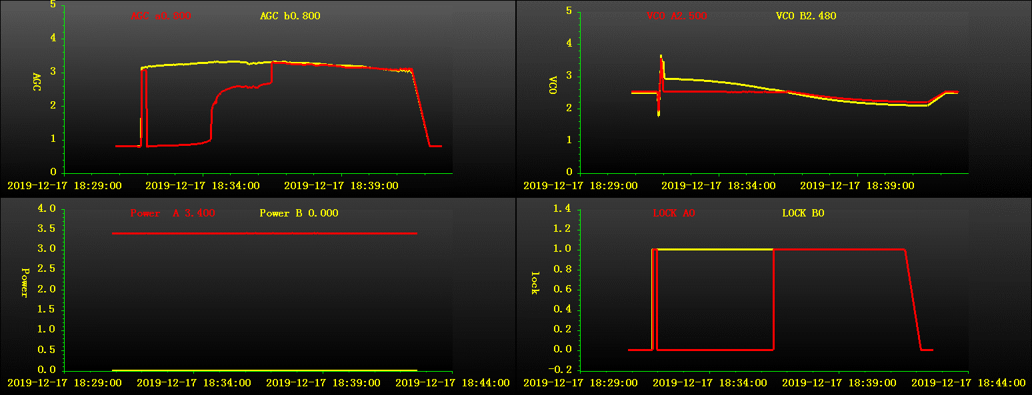
Figure 1: Both transponders locking and then transponder A unlocking soon afterwards.
- The 2nd evening pass was scheduled as per the following parameters:
Pass time | 18:30:59 to 18:41:33
Orbit no. | 7773
Work mode | TM+TC+RNG
Task Strategy | SCC
Azimuth range | 197.283~327.337
Max. elevation | 24.300
Fundamental mode | Auto/Program Track
- At about 18:36:29 UTC transponder A got locked once again at elevation of 24.03 deg without any manual intervention. Respective AGC and VCO voltages shown in figure 2 and figure 3 pasted below, but, transponder B remined locked all the time.
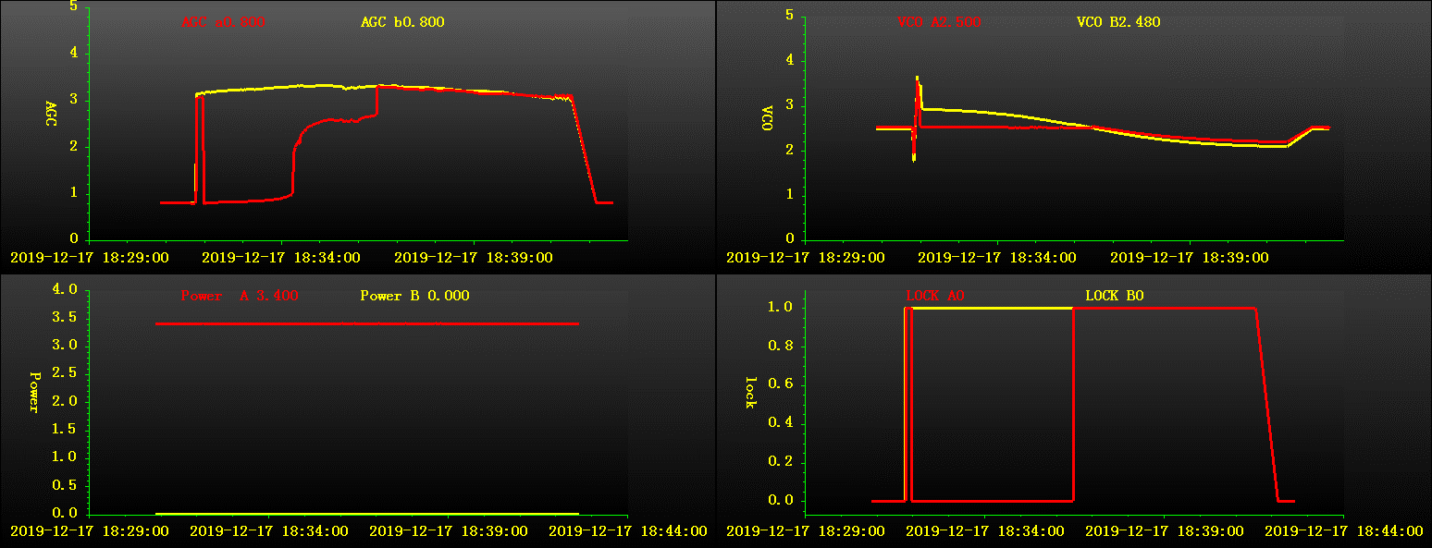
Figure 2: Abrupt transponder unlocking mid-pass
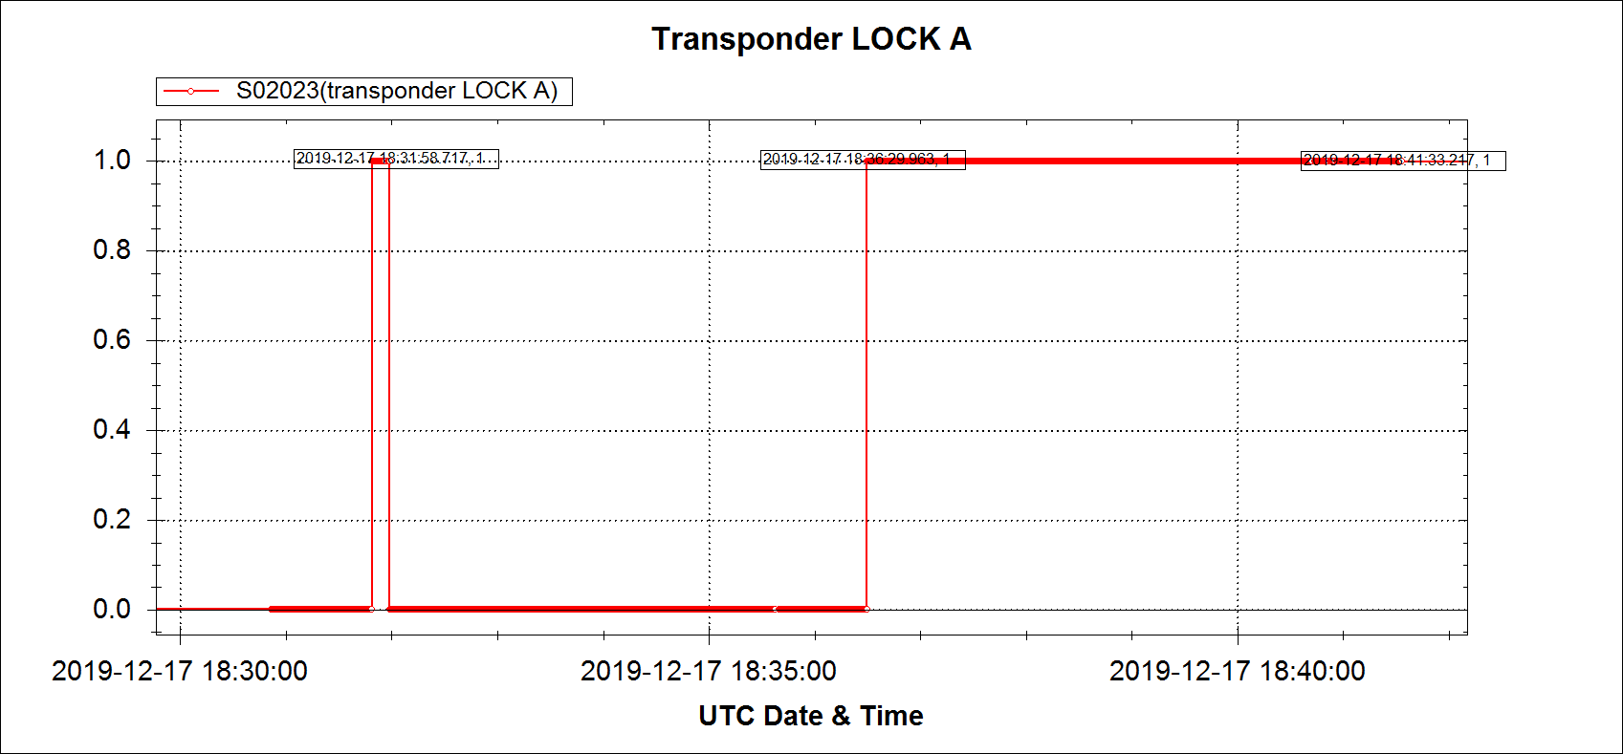
Figure 3 Transponder A locking and Unlocking
- Pasted below are screenshots of plotted S-band data of relevant TMs (Figure 4)
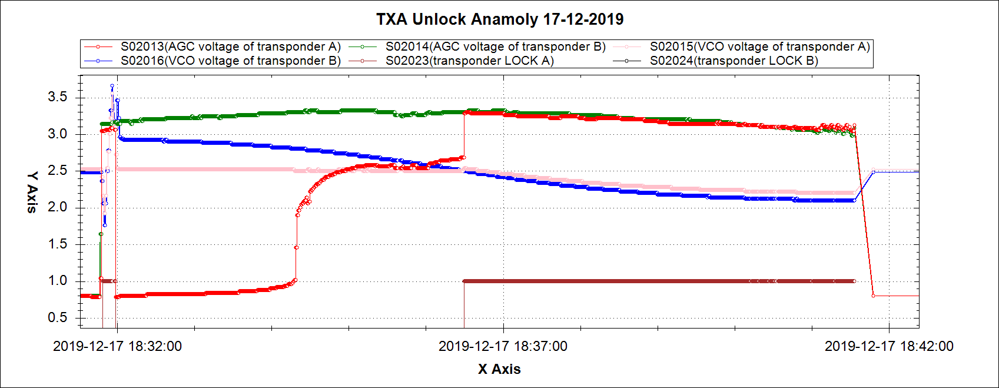
Figure 4 TMs Plots for Transponders A & B.
- Moreover, another issue seemed to have occurred with ranging during the anomalous time period of transponder A. Ranging has started at 23.6 degrees at 18:35:43 UTC.
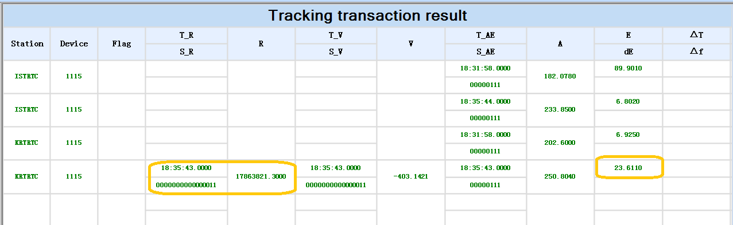
Figure 5 Ranging Start Time GIDS Page
- Due to unlocking of Transponder A, ranging data was missed and Ranging was started at 18:37:08 UTC after the Transponder A was locked again at 18:36:29 UTC as can be seen in figure 6 pasted below.
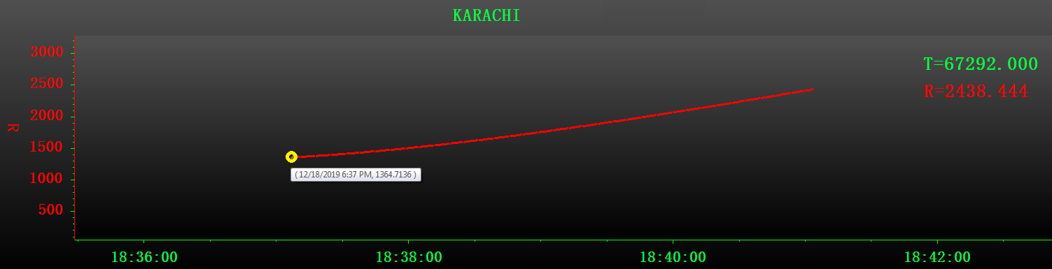
Figure 6 Ranging Data on GIDS
- At Ground Station, it was observed that the ACU fundamental mode remained in “Program Track” after pass had started. The AGC Voltage was below the threshold Voltage of 1.8V. The ACU remained in program track till 18:31:59 UTC.
- However, the Fundamental mode was fluctuated from Auto track to program track thrice, during the pass. ACU log is mentioned below in Figure 7.
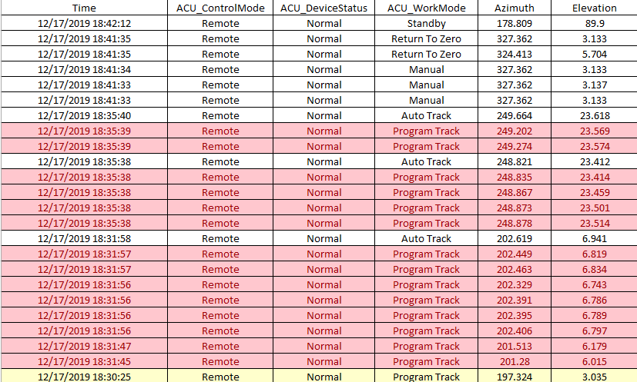
Figure 7 ACU Log
- The SSPA 1 showed normal behavior according to the logs on MCS.
Status:

- Despite showing anomalous behavior for a brief duration of time, transponder A recovered and performed normally for the rest of the pass. All satellite TMs and parameters were normal.
Contractor Remarks (Insert Date):

Please insert date and type in green font

CLOSED / OPEN | OPEN

